Website corrections points – V5

- Need to classify under Lidar Annotation as below (Like classified under Image annotation)
3. Lidar Annotation
+ 3D Cuboids Annotation
+ 3D Semantic Annotation
- We need to add a G- Meet Link in schedule an appointment ( Need to add Plug in. It has been Discussed with Prashanth)
under that we need to add a G - meet link with the time and Date selection option
Please refer below images
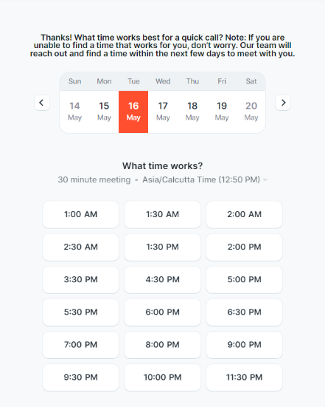
Email should go to them like below
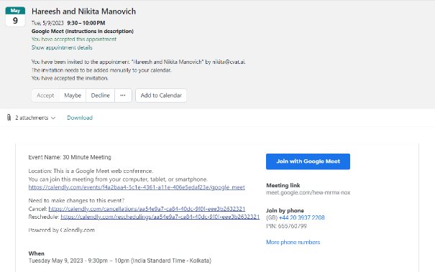

- place the heading of the service over the Main image for all types of services
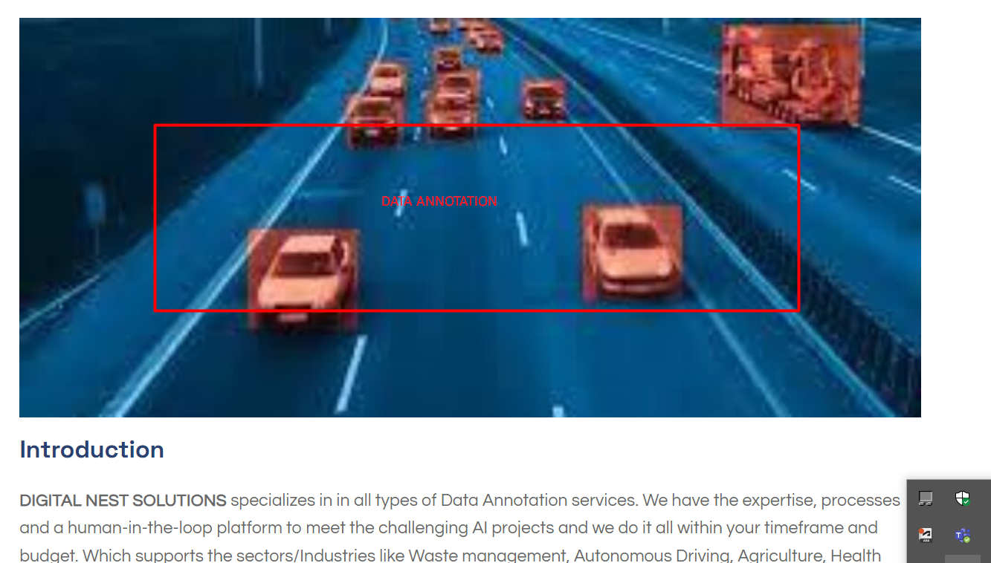

- Extend blue color to match other two rectangles
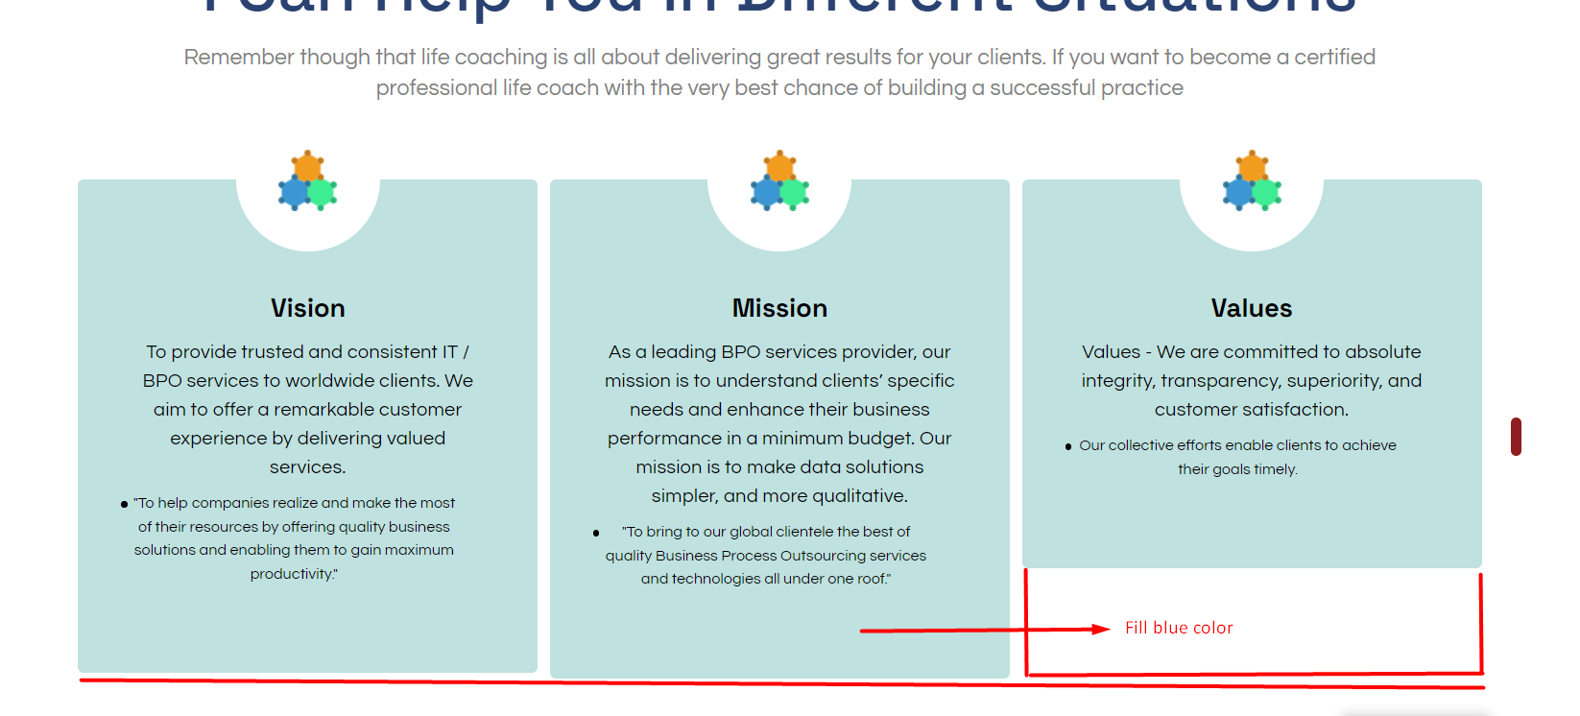

- Make a marked place as heading and give background colour to look more attractive
And keep this description only under PV Design services
Make sure to keep the uniformity for Achievements and Expertise
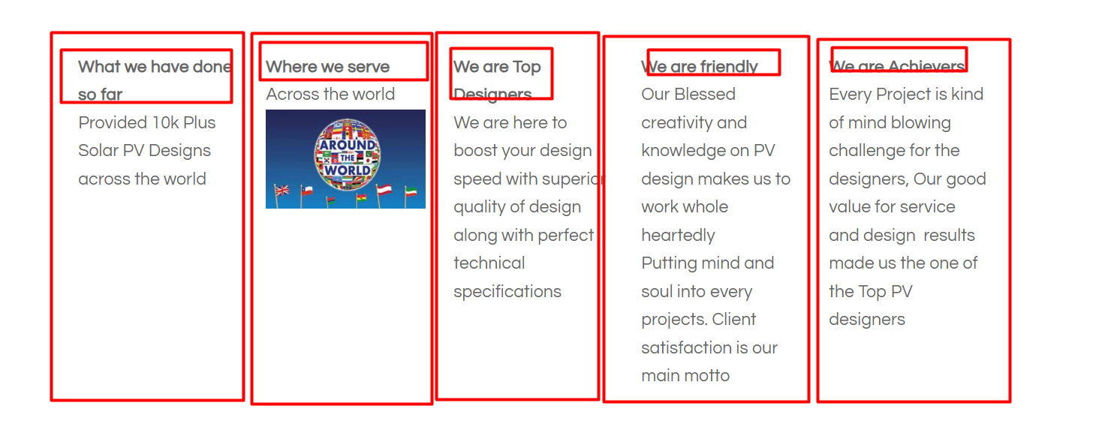
- Update the below Description for Data annotation and Interior Design Services
1. What we have done so far
Provided 10k Plus Projects across the world
2. Where we serve
Across the world
(Image Attached)
3. We are Top Designers
We are here to boost your design speed with superior quality of design along with perfect technical specifications
4. We are friendly
Our Blessed creativity and knowledge on Design makes us to work whole heartedly
Putting mind and soul into every projects. Client satisfaction is our main motto
5. We are Achievers
Every Project is kind of mind blowing challenge for the designers, Our good value for service and design results made us the one of the Top Service Providers
- Under Landmark Annotations
Arrange the images and Words Properly
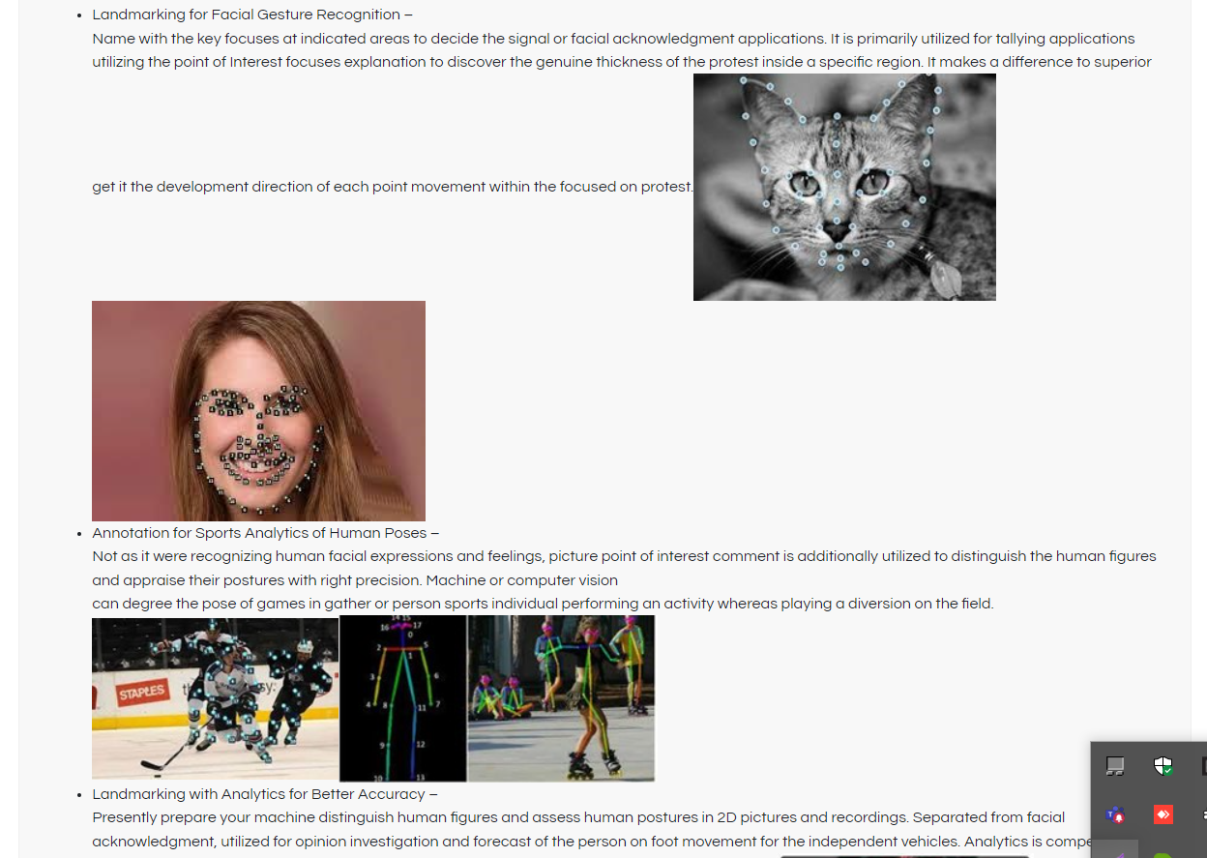
- Remove the unnecessary Blank spaces in the website
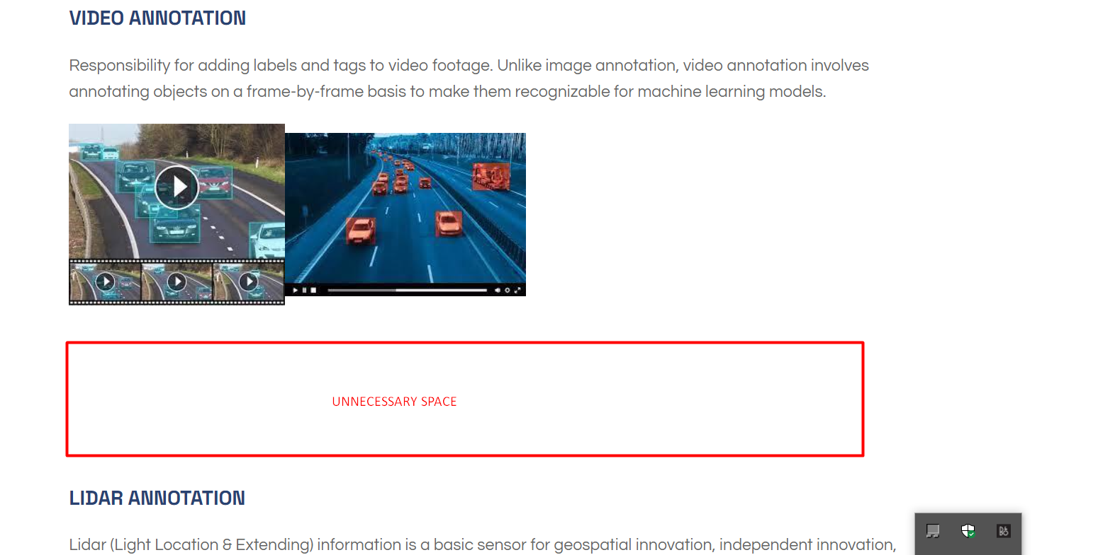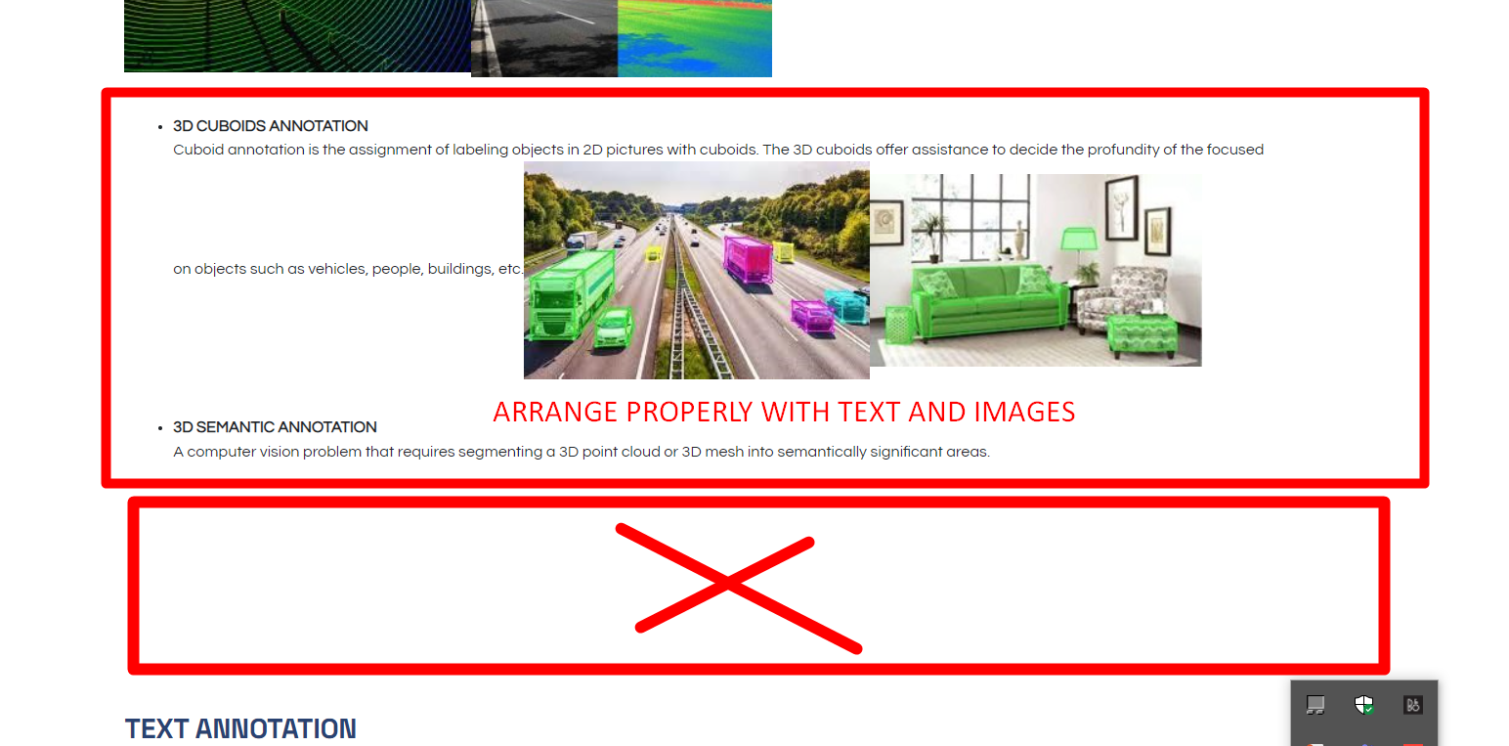
- Remove the below from Home Page
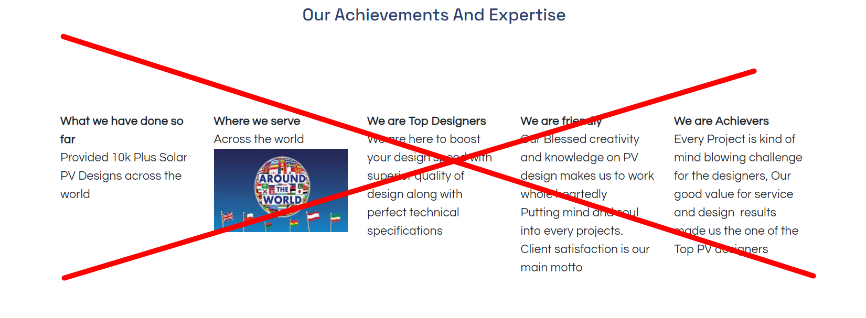
- A) High Resolution images have been attached for all services
B) Update the images for Data Annotation.
C) Make sure all the images maintain uniformity with Size
D) Use the high resolution images for heading images for all services
- Remove the below images
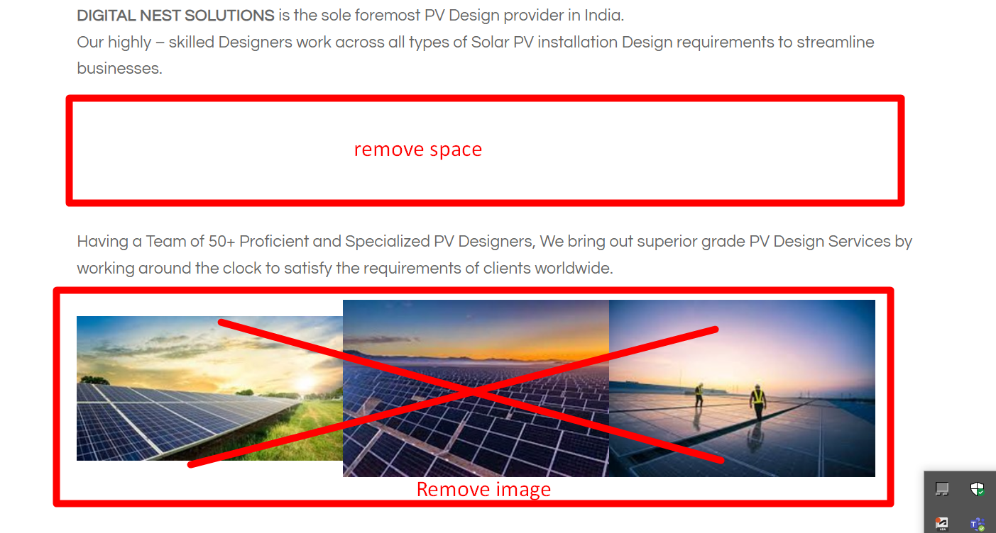
- Remove the Explore now Tab and link


